CHAPTER NO 11

NETWORK AND INTERNET

COMPUTER NETWORK
DEFINATION:
“A computer network is a group of computers which are connected together to allow communication between them.”
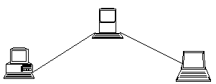

TYPES OF NETWORK
There are two main types of network :
- LAN
- WAN

LOCAL AREA NETWORK (LAN) :
Definition: “A network which is located entirely on one site such as an office, school or within a group of buildings that are in close proximity, that are connected together.”

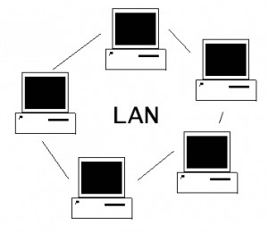

WIDE AREA NETWORK (WAN) :
“A network which connects together computers on a number of sites in different areas”.
A WAN or Wide Area Network is a group of widely dispersed computers that are connected together. These could be across the same town, or across a country or even across the world”.
Apart from distance, the other feature that distinguishes as WAN from a LAN is that the WAN would make use of a range of communication technologies such as telephone, microwave and satellite links.
Using a WAN, schools in Florida can communicate with places like Tokyo in a matter of minutes, without paying enormous phone bills. A WAN is complicated.
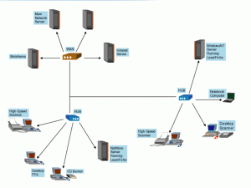

ADVANTAGES OF NETWORK

- SPEED.
Networks provide a very rapid method for sharing and transferring files. Without a network, files are shared by copying them to memory cards or discs, then carrying or sending the discs from one computer to another. This method of transferring files can be very time-consuming.
- COST.
Networkable versions of many popular software programs are available at considerable savings when compared to buying individually licensed copies.
- SECURITY.
Files and programs on a network can be designated as "copy inhibit," so that you do not have to worry about illegal copying of programs. Also, passwords can be established for specific directories to restrict access to authorized users.
- CENTRALIZED SOFTWARE MANAGEMENT.
One of the greatest benefits of installing a network at a school is the fact that all of the software can be loaded on one computer (the file server). This eliminates that need to spend time and energy installing updates and tracking files on independent computers throughout the building.
- RESOURCE SHARING.
Sharing resources is another advantage of school networks. Most organizations cannot afford enough laser printers, fax machines, modems, scanners, and CD players for each computer. However, if these or similar peripherals are added to a network, they can be shared by many users.
- ELECTRONIC MAIL.
The presence of a network provides the hardware necessary to install an e-mail system. E-mail aids in personal and professional communication for all personnel, and it facilitates the dissemination of general information to the entire staff. Electronic mail on a LAN can enable students to communicate with teachers and peers at their own institute. If the LAN is connected to the Internet, we can communicate with others throughout the world.
- FLEXIBLE ACCESS.
Networks allow users to access their files from computers throughout the institute. Like Students can begin an assignment in their classroom, save part of it on a public access area of the network, then go to the media center after school to finish their work. Students can also work cooperatively through the network.
- WORKGROUP COMPUTING.
Collaborative software allows many users to work on a document or project concurrently. For example, educators located at various schools within a county could simultaneously contribute their ideas about new curriculum standards to the same document, spreadsheets, or website.

NETWORK TOPOLOGY
Network topology refers to the layout used to wire the computers together.
TYPES OF TOPOLOGY
There are four main topologies that are used.
- BUS
- STAR
- RING
BUS TOPOLOGY
Each computer is connected to a single cable which connects all of the computers. All nodes (file server, workstations, and peripherals) are connected to the linear cable.
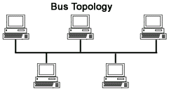

Advantages of Bus Topology
- Easy to connect a computer or peripheral to a linear bus.
- Requires less cable length than a star topology.

Disadvantages of a Bus Topology
- Entire network shuts down if there is a break in the main cable.
- Terminators are required at both ends of the backbone cable.
- Difficult to identify the problem if the entire network shuts down.
- Not meant to be used as a stand-alone solution in a large building.
STAR TOPOLOGY
“All communication takes place via a central computer or HUB device.”
A star topology is designed with each node connected directly to a central network hub, switch, or concentrator.
Data on a star network passes through the hub, switch before continuing to its destination. The hub, switch, or concentrator manages and controls all functions of the network. It also acts as a repeater for the data flow.
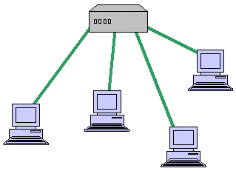

Advantages of a Star Topology
• Easy to install and wire.
• No disruptions to the network then connecting or removing devices.
• Easy to detect faults and to remove parts.
Disadvantages of a Star Topology
• Requires more cable length than a linear topology.
• If the hub or concentrator fails, nodes attached are disabled.
• More expensive than bus topologies because of the cost of the HUB device.

RING TOPOLOGY
Each computer is connected to the two computers on either side of it. The last computer is linked to the first to form a ring.
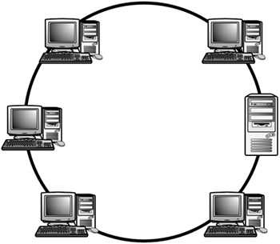

Advantages of a Ring Topology
• Easy to install and wire.
• Equal Access to devices no one computer will use all the bandwidth
• Easy to detect faults and to remove parts.
Disadvantages of a Ring Topology
• Slow since signals goes in sequential order
• If the concentrator fails, nodes attached are disabled.
• Single break in cable can disrupt the flow of network.

INTERNET

DEFINATION:
Internet is global “Network of Networks”. The internet is a worldwide public network of computers on which people can join and use multiple services such as sharing of information.
By internet users at any one computer can get information from any other computer.
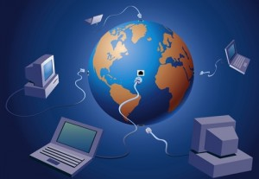

HISTORY OF INTERNET
It was developed by the United States Defense Advanced Research Projects Agency in the 1970s and was initially known as ARPANET.
The Internet was designed to be used by companies and Universities doing military research so that they could share information. Since then the number of people who use the Internet and the services that are provided on the Internet have grown tremendously. There are now over 200,000,000 people who regularly make use of it.

CONNECTING METHODS TO THE INTERNET
To connect to the Internet the following are needed:
- a computer
- telephone line
- modem and/or router
- an ISP (Internet Service Provider)
- Web browser, e.g. Internet Explorer, Firefox, Chrome, Safari, Opera etc.
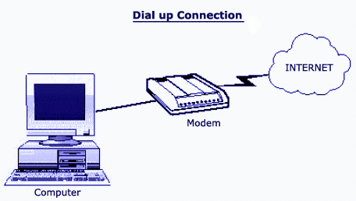

WHAT IS MODEM?
A device which convert analog signals to digital signals and digital signals to analog for transmitting data over internet.

WHAT IS WEB BROWSER?
Web Browser is Software used to display the Web pages. Internet explorer is an example of web browser
Here are some types of web browser:
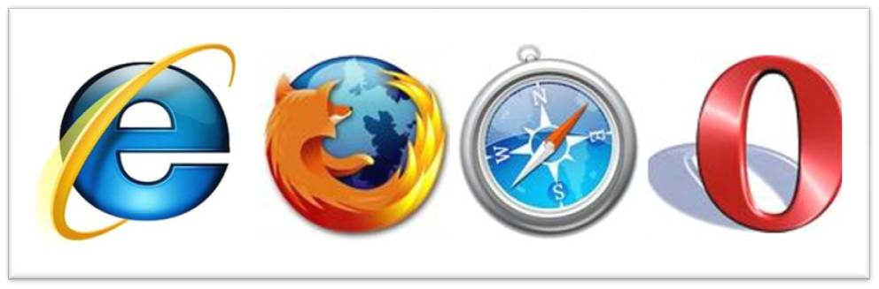
- Internet explorer
- Firefox
- Chrome
- Safari
- Opera

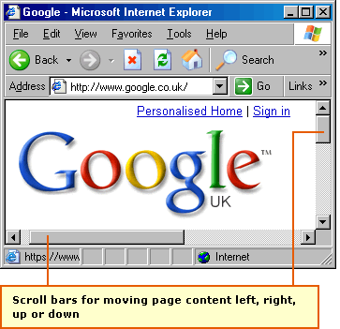

WHAT IS WEB SITE ADDRESS?
Every web site has a specific address which is also called URL that is Uniform Resource Locator.
EXAMPLE:
http://www.paknews.com

HTTP: Hyper Text Transfer Protocol, is rule to send and receive text on internet
WWW: World Wide Web, It consists of a large number of web servers that host websites. Each website will normally consist of a number of web pages. A web page can contain text, images, video, animation and sound.
Paknews: Domain Name
Com: type of web site there are many other types of web sites like
Pak: Pakistan
Edu: education
Mil: military
Gov: govt
Com: commercial

ADVANTAGES OF INTERNET
There many advantages to using the internet such as:
- Email.
- Sharing Information.
- Services.
- Buy or sell products.
- Communities.
- News
- Searching jobs
- Advertisement
- Communication
- Entertainment
- Online education
- Online education and research
DISADVANTAGES OF INTERNET
Although there are huge advantages of internet but there is always another side of picture.
So internet has some disadvantages like
- Viruses
- Security problem
- Immorality
- Many information is not accurate
- Wastage of time
EMAIL
Electronic Mail (email) is a system which allows users of a computer network to send messages to each other. Users can usually:
- Send a message to another user, or group of users.
- Keep their messages in a mailbox.
- Read, print and delete messages from their mailbox.
It is not only typewritten messages that can be sent using Electronic Mail. Pictures, music, videos, in fact almost any sort of information you can think of, can also be sent.
Each user has to have his or her own address that other users need to know to send messages to him or her.
Electronic mail is good because it is much faster that the ordinary post. It is also very accessible since you can read your email on any suitable computer anywhere in the world. On the other hand not everybody has an electronic mailbox at the moment, so you cannot use email to send messages to everyone, and you certainly can’t send a parcel by email.
There are many email service provider companies which allow any user to send and receive electronic mail like
- Hotmail
  - www.hotmail.com
- Yahoo
  - www.yahoo.com/mail
- Gmail
  - www.gmail.com

WHAT IS SEARCH ENGINE

“Internet search engines are special sites on the Web that are designed to help people find information stored on other sites.”
Tool for finding information, especially on the Internet or World Wide Web. Search engines are essentially massive databases that cover wide swaths of the Internet. Search engines are the primary method Internet surfers use to locate information on the Web.
We can search any information by use of search engines. There are thousands of different search engines to help people navigate the Internet. These include major commercial search engines—like Yahoo!, Lycos, AltaVista, and Excit, as well as many smaller, industry-specific directories. There are even Meta searchers, which work by querying a number of other search engines and processing the results.
Many of the major search engines are created through an automated process in which a program called a spider "crawls" across the Web to gather information about existing sites. The spider captures this basic information and organizes its findings into categorizes, which are then used to generate search results for users. Small businesses hoping to list an existing Web site with a major search engine may find that the process has already been completed for them by an automated spider

Major search engines URLs are define below:
Yahoo: www.yahoo.com
Google: www.google.com
Alta vista: www.altavista.com
Lycos: www.lycos.com
Msn: www.msn.com

